**Project Report**

**INTRODUCTION**

OVERVIEW

Agriculture is a unique sector which depends on weather conditions. The backbone of the Indian economy is agriculture, which is the most important occupation for Indian families. The two main food staples in the world, rice and wheat, are produced in India in second place. The agriculture sector of India has occupied almost 43 percent of India’s geographical area.

PURPOSE

India's food security depends on producing cereal crops, as well as increasing its production of fruits, vegetables and milk to meet the demands of a growing population with rising incomes.

**PROBLEM DEFINITION & DESIGN THINKING**

**EMPATHY MAP**

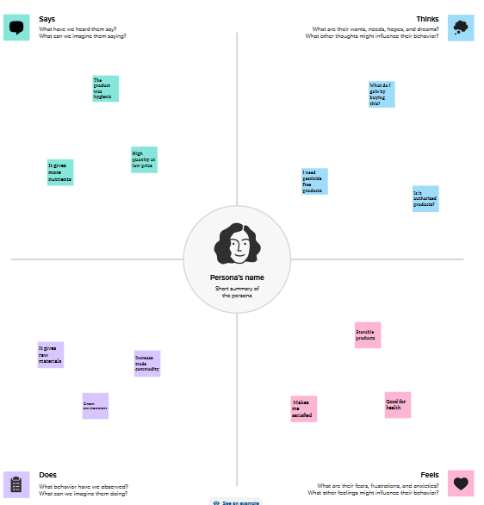

**IDEATION & BRAINSTROMING MAP**

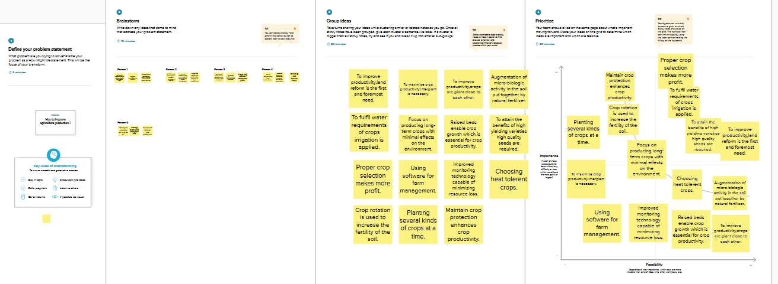

**RESULT**

TOP 5 CROP PRODUCING STATES

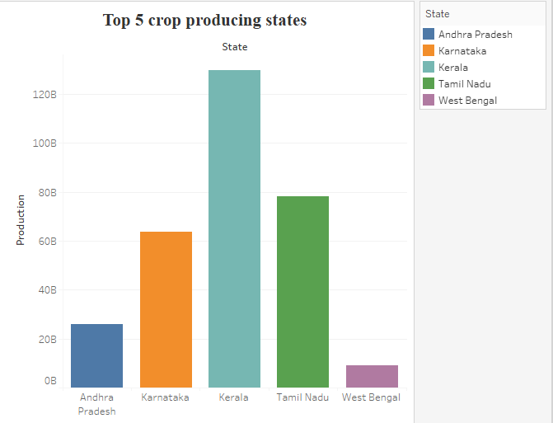

CROPS GROWING AREA

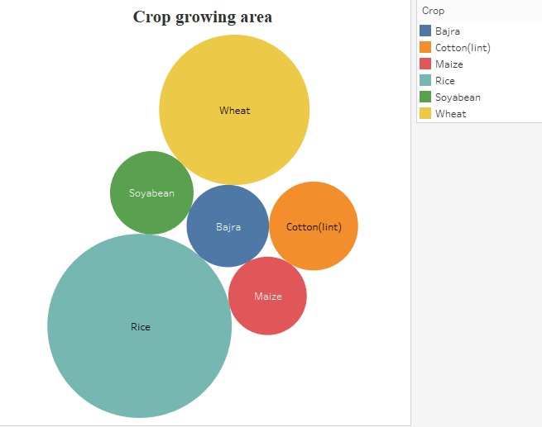

CROP YIELD IN THE YEAR OF 2011-12

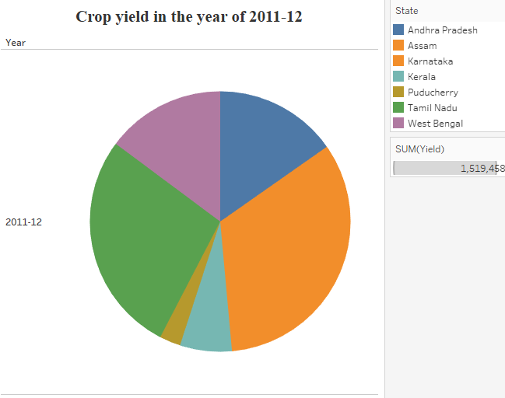

STATE WISE YIELD

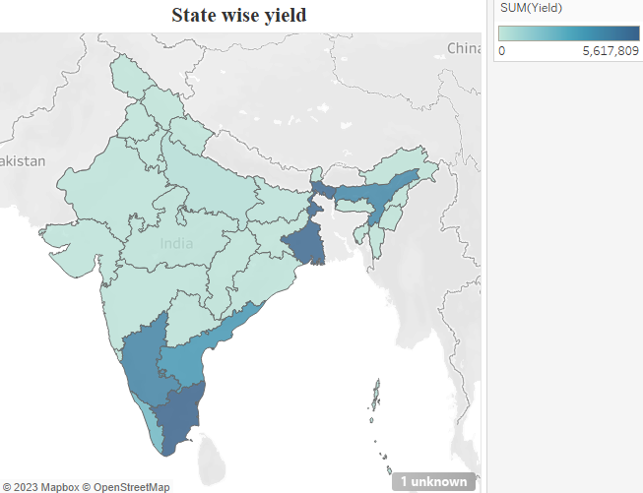

YEAR WISE PRODUCTION

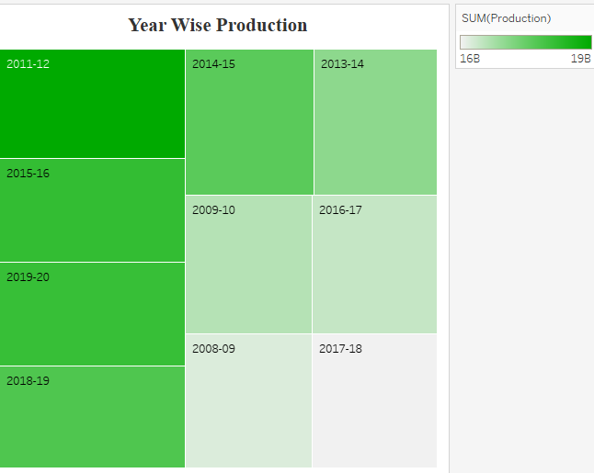

DASHBOARD

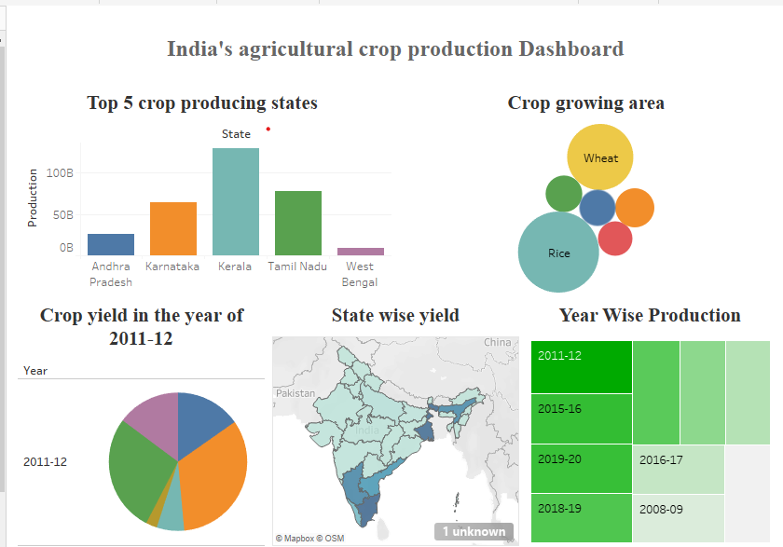

STORY

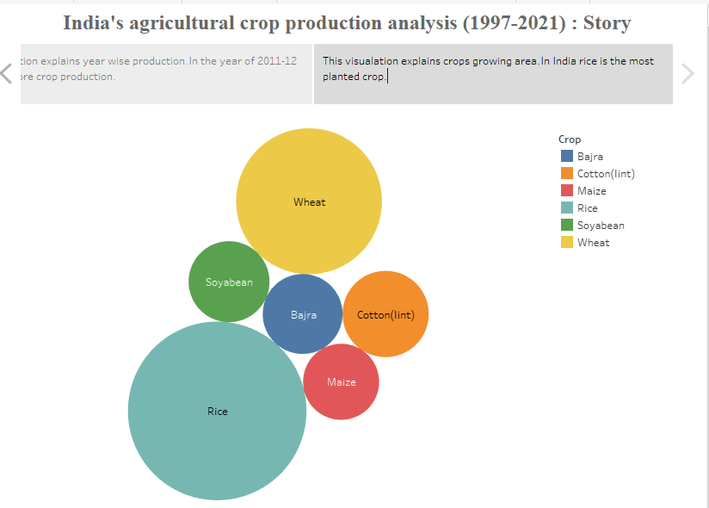

**ADVANTAGES & DISADVANTAGES**

Advantages of India’s agricultural crop production analysis

* The selection of crop to yield good production in the selective area was investigated.
* Year wise development of the agricultural sector was analyzed particularly for top 10 years.
* Which production was cultivated highly in the year 2011-12 was evaluated.
* State wise yielding in India was examined and what are the ways to increase the crop production in lowest yielding area will be find out.

Disadvantages of India’s agricultural crop production analysis

The way for yielding good production cannot be investigated was the only disadvantage of this analysis.

**APPLICATIONS**

* This analysis is used for increasing the productivity.
* This analysis encouraging economic development.
* Applied in trading and business.

**CONCLUSION**

Kerala is top level in crop production .In India, rice is the most planted crop and India is the second largest producers. In the year of 2011-12 Tamil Nadu produces high level yielding than others. South and East India has high level crop yield.

**FUTURE SCOPE**

To feed a huge and expanding population. The way of yielding good production will be investigated. Season wise crop plantation will be examined.

**APPENDIX**

[**https://www.ncmrwf.gov.in/NCMRWF_REPORT.pdf**](https://www.ncmrwf.gov.in/NCMRWF_REPORT.pdf)

[**https://online.maryville.edu/blog/why-is-agriculture-important/**](https://online.maryville.edu/blog/why-is-agriculture-important/)